
Data Analysis Course Project Report on
“The World Happiness Index: Data Integration and Trend Mapping”
SUBMITTED IN PARTIAL FULFILLMENT OF THE REQUIREMENTS FOR THE DEGREE OF

BACHELOR OF TECHNOLOGY IN
“Computer Science”
OF VISHWAKARMA INSTITUTE OF TECHNOLOGY
Savitribai Phule Pune University
Gayatri (1251070299)
Anshuman (1251070994)
Arjun(1251071053)
Aqdas(1251070303)
UNDER THE GUIDANCE OF

“prof. DR. Vinod Kimbhahune”



DEPARTMENT OF ENGINEERING SCIENCE AND HUMANITIES
BANSILAL RAMNATH AGARWAL CHARITABLE TRUST’S
VISHWAKARMA INSTITUTE OF TECHNOLOGY
(An Autonomous Institute affiliated to Savitribai Phule Pune University)
2025 - 2026
BANSILAL RAMNATH AGARWAL CHARITABLE TRUST’S
VISHWAKARMA INSTITUTE OF TECHNOLOGY
(An Autonomous Institute affiliated to Savitribai Phule Pune University)

PUNE – 411037.



CERTIFICATE
This is to certify that the Course Project titled “The World Happiness Index: Data Integration and Trend Mapping” submitted by Gayatri Ambhore (1251070299), Anshuman Saxena (1251070994), Arjun Honrao (1251071053), Aqdas Khan (1251070303) is in partial fulfilment for the award of Degree of Bachelor of Technology in DESH of Vishwakarma Institute of Technology, Savitribai Phule Pune University. This project report is a record of Bonafide work carried out by him under my guidance

during the academic year 2025-26.

Place: VIT, Pune
Date:18/05/2026

HOD, DESH:
Prof. Dr. Shilpa Lambore
Guide:
Prof. Dr. Vinod Kimbhahune sir

Bansilal Ramnath Agarwal Charitable Trust’s
Vishwakarma Institute of Technology, Pune-37
Department of Engineering Science and Humanities

PROJECT DETAILS
Group No : 01
Members: 05

Roll No. | PRN | Name of Student | Contact No. | Email ID
52 | 1251070299 | Gayatri Ambhore | 7775834312 | gayatri.1251070299@vit.edu
59 | 1251070994 | Anshuman Saxena | 7385216556 | anshuman.1251070994@vit.edu
70 | 1251071053 | Arjun Honrao | 8624971251 | arjun.1251071053@vit.edu
66 | 1251070303 | Aqdas Khan | 9049273995 | aqdaskhan.1251070303@vit.edu

Project Title: The World Happiness Index: Data Integration and Trend Mapping

Project Area: Data Analysis
Internal Guide: Prof. DR. Vinod Kimbhahune
Signature of Internal Guide

ACKNOWLEDGEMENT
We would like to express our sincere gratitude to our project guide, teachers, and institution for their valuable guidance, support, and encouragement throughout the development of this project. We are also thankful to all the respondents who contributed survey data, which played an important role in the successful completion of the dashboard analysis. Finally, we appreciate the support of our teammates, friends, and family members for their continuous motivation and cooperation during the project work.this journey.
Lastly, we extend our thanks to my family and friends for their encouragement and
unwavering support.

Introduction
The World Happiness Index is a landmark survey that measures global happiness and subjective well-being across more than 150 nations. Commissioned annually by the United Nations Sustainable Development Solutions Network (SDSN), the report relies on nationally representative Gallup World Poll data, where respondents rate their own lives on a scale from 0 to 10 (the Cantril ladder). This project, titled "The World Happiness Index: Data Integration and Trend Mapping," is built to integrate, analyze, and visualize the global happiness datasets for the years 2024 and 2025 using Microsoft Power BI. By examining crucial socio-economic variables—such as Gross Domestic Product (GDP) per capita, social support systems, healthy life expectancy, freedom to make life choices, generosity, and public perceptions of corruption—this project maps global wellness trends and highlights patterns of disparity across different regions and countries. The dynamic dashboard serves as a critical decision-support tool for economists, policy makers, and sociologists aiming to study the factors that foster human well-being.

Data Analysis Expressions (DAX) is the formula language used in Microsoft Power BI to build custom calculations and dynamic metrics. In this project, multiple advanced DAX measures are developed to compute key performance indicators (KPIs) and drive the interactive visuals across the dashboard sheets:
- Average Happiness: Computes the mean happiness score across all surveyed nations using AVERAGE('2024'[Happiness score]) or AVERAGE('2025'[Happiness Score]).
- Total Countries: Determines the count of unique countries analyzed using DISTINCTCOUNT('2024'[Country ]) or DISTINCTCOUNT('2025'[Country]).
- Happiest Country: Identifies the country with the maximum happiness score in a given year using CALCULATE and MAXX.
- Healthiest Nation: Evaluates the country with the highest healthy life expectancy rating by comparing average health factors.
- Slicers & Filters: Built-in interactivity for selecting specific countries and comparing 2024 vs 2025 report values.
- Dynamic Charts (PIE CHART, CLUSTERED COLUMN, LINE CHART): Visualizes country category counts, economic correlations, and yearly trend lines.

Literature Survey
- Helliwell et al. (World Happiness Reports) establish that subjective well-being can be reliably measured and compared internationally using the Cantril life ladder scale.

- Diener et al. show that while economic prosperity (GDP per capita) correlates strongly with national happiness, social support and freedom of choice are equally vital contributors.

- Kahneman and Deaton demonstrate that emotional well-being rises with income, but only up to a certain threshold, after which non-economic factors dominate happiness levels.

- Business intelligence (BI) frameworks like Microsoft Power BI provide powerful data modeling environments to analyze multi-dimensional socio-economic datasets effectively.

- Researchers emphasize the importance of data integration from multiple annual cycles to map long-term trends and identify geographic shifts in national well-being

- Geographic information systems (GIS) and interactive map visualizations in BI tools improve user engagement and facilitate rapid regional comparison of global indices.

- Advanced DAX modelling in Power BI enables the creation of dynamic, responsive KPIs that update in real-time as users filter reports by region or year.

- Comparative analysis of sequential years (e.g., 2024 vs. 2025) helps researchers assess the direct impact of global events (like pandemics or economic inflation) on well-being.

- Studies show that freedom of choice and generosity act as social cushions, mitigating the negative effects of economic crises on overall life satisfaction.

10. Dynamic dashboards act as critical tools for public policy planning, helping governments allocate resources toward social infrastructure and healthcare.

Methodology
- Data Collection: Sourcing official annual datasets from the World Happiness Report publications for the consecutive years 2024 and 2025.

- Data Storage & Organization: Staging the raw datasets in CSV and Microsoft Excel formats for preparation and modelling.

- Data Cleaning & Preprocessing: Standardizing country names across years (e.g., fixing spacing and special characters), handling missing or null values in columns like GDP or Freedom, and adding a Happiness Category classification column (Highly Happy, Moderately Happy, Low Happy) based on score thresholds.

- Data Importing: Loading the prepared 2024 and 2025 datasets into the Microsoft Power BI Desktop modelling engine.

- Data Modelling & Integration: Establishing relationships between the 2024, 2025, and a unified comparison dataset to support cross-filtering and multi-year analysis.

- DAX Measure Implementation: Developing key measures in DAX for metrics like Average Happiness, Total Countries, and Top Country for both 2024 and 2025 reports.

- Dashboard Development: Designing three dedicated report pages: '2024 Report' (for 2024 analysis), '2025 Report' (for 2025 analysis), and 'World Happiness Report: 2024 vs 2025' (for multi-year comparative tracking).

- Trend Mapping & Insights: Using visual analytics (like line charts and clustered columns) to map positive/negative shifts in global happiness and generate comprehensive policy insights.

Features provided by a Tool

Microsoft Power BI Features:
- Interactive Multi-Page Reports: Provides seamless page navigation and cohesive design templates
- Advanced DAX Query Engine: Enables dynamic, high-speed calculations of custom socio-economic metrics.
- VertiPaq Data Compression: Compresses huge datasets in-memory for lightning-fast query execution.
- Geographical Map Integration: Offers interactive, location-based bubble mapping for country-level analysis.
- Dynamic Cross-Filtering: Selecting a category in one visual automatically filters all other visuals on the report page.
- User-Friendly Drag-and-Drop Interface: Facilitates rapid dashboard design and visual customization.
- Custom Slicers and Filters: Supports flexible, real-time data slicing by country, year, or happiness tier.
- Interactive Tooltips: Displays customized, detailed metadata when hovering over data points on a chart.
- Diverse Visual Library: Features an extensive range of native visuals including cards, pie charts, maps, column charts, and line graphs.
- Data Connectivity: Connects seamlessly to a wide range of data sources including CSV, Excel, SQL, and Web APIs.
- Power Query ETL Engine: Simplifies data cleaning, merging, and transformations through a robust visual editor.
- Automated Layout Optimization: Supports creating separate, customized layouts optimized for mobile devices.
- Role-Based Security: Provides robust security measures to restrict data access based on user roles.
- Easy Cloud Sharing: Supports publishing reports directly to the Power BI Service for secure online collaboration.
- Continuous Product Updates: Frequently updated by Microsoft with new AI features, visual types, and performance enhancements.

Screenshots of Analyzed Dashboards

Below are the screenshots of the Microsoft Power BI World Happiness Report Dashboard

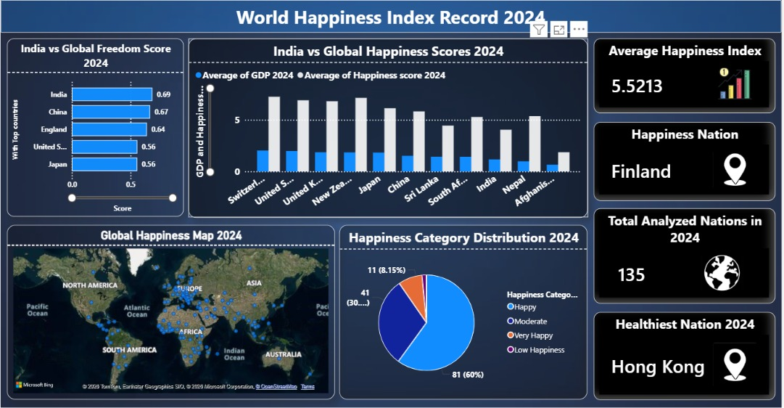
Figure 1: 2024 World Happiness Report Dashboard - High-level country indicators, map, category breakdown, freedom scores, and GDP/happiness correlation
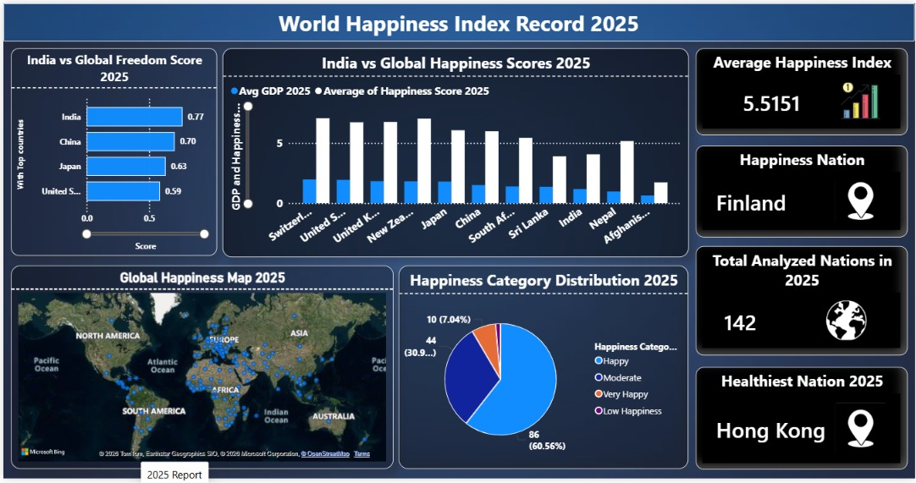
Figure 2: 2025 World Happiness Report Dashboard - Current year score mappings, freedom scores, and key indicators.

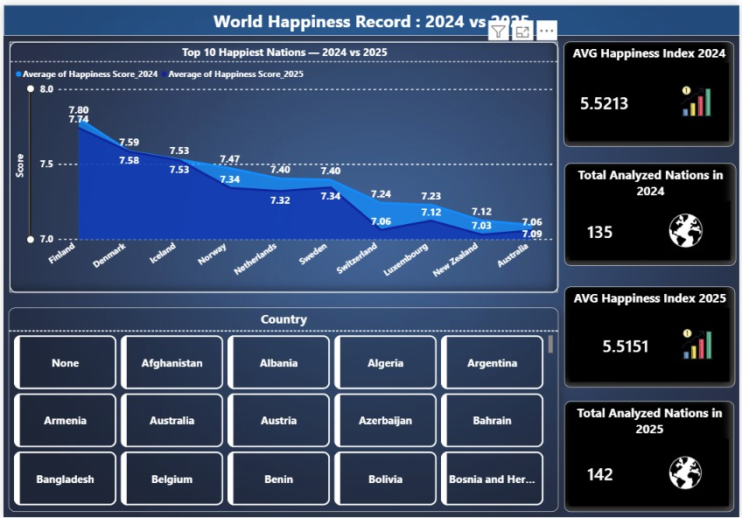
Figure 3: World Happiness Report: 2024 vs 2025 Comparison Dashboard - Comparative trend lines and country-wise analysis toolkits.

Conclusion:

The World Happiness Index Data Integration and Trend Mapping project successfully demonstrates the power of business intelligence and data analytics in studying global well-being. By integrating multi-year datasets (2024 and 2025) into an interactive Microsoft Power BI dashboard, the project reveals significant regional disparities and shifts in happiness scores. Factors such as Gross Domestic Product (GDP) per capita, healthy life expectancy, and social freedom remain the strongest drivers of life satisfaction globally. The dynamic dashboard provides an accessible, high-performance interface for comparing national and regional metrics, highlighting how data visualization can translate complex socio-economic indicators into actionable public policy insights.

Advantages:
- Facilitates easy visualization of complex, multi-year global happiness datasets.
- Supports informed policymaking by highlighting critical areas of low well-being.
- Simplifies regional comparisons through interactive geographical map visualizations.
- Offers high-speed metric calculations using the Power BI DAX calculation engine.
- Enables dynamic, real-time filtering of datasets by year, country, or happiness tier.
- Automates KPI updates (like Average Happiness) across all dashboard pages.
- Saves hours of manual work compared to traditional static spreadsheet reporting.
- Encourages user interaction through cross-filtering and rich visual tooltips.
- Integrates multiple data tables into a single cohesive, unified relational schema.
- Promotes public awareness by making socio-economic data accessible and engaging.
- Enhances visual data storytelling using harmonious color palettes and clean layouts.
- Visualizes the correlation between economic indicators (GDP) and emotional well-being.
- Minimizes overall project cost by using free Power BI Desktop software.
- Supports seamless data cleaning and transformation using Power Query ETL.
- Helps identify positive or negative trends in national happiness over time.

Limitations

Relies heavily on the accuracy and subjective honesty of Gallup survey responses.

Small annual changes in scores may not reflect actual structural shifts in national well-being.

Cultural differences in interpreting happiness scales can introduce country-level bias.

The dashboard displays static historical data and does not support real-time streaming updates.

Internet connectivity is required to access advanced map features and cloud sharing.

Power BI Desktop requires a dedicated installation and does not run natively on macOS.

Manual data cleaning is necessary to reconcile spelling variations in country names.

The dashboard does not include predictive machine learning algorithms for forecasting.

Processing extremely large multi-decade datasets can increase report loading times.

Visual customization within native Power BI charts can sometimes be limited.

Future Scope
- Integrating real-time sentiment analysis using social media APIs to monitor daily public mood.
- Developing machine learning regression models to forecast happiness score shifts.
- Deploying the dashboard on Power BI Service with scheduled automated data refreshes.
- Creating a dedicated mobile application layout for on-the-go policy analysis.
- Adding an AI-driven 'Key Influencers' visual to mathematically isolate happiness drivers.
- Integrating local government databases to study correlations between local policies and well-being.
- Enhancing geographical maps with interactive layers showing regional socio-economic indices.
- Introducing secure user authentication for restricted collaborative research.
- Generating automated PDF analytical summaries and email alerts for stakeholders.
- Expanding the data scope to cover historical happiness data from the past two decades.

References

Helliwell, J. F., Layard, R., Sachs, J. D., De Neve, J.-E., Aknin, L. B., & Wang, S. (Eds.). World Happiness Report. Sustainable Development Solutions Network.

2. Microsoft Power BI Official Documentation & DAX Language Reference Guide.

3. Ferrari, A., & Russo, M. The Definitive Guide to DAX: Business Intelligence with Microsoft Power BI, SQL Server Analysis Services, and Excel. Pearson Education.

4. Diener, E., Lucas, R. E., & Oishi, S. Subjective Well-Being: The Science of Happiness and Life Satisfaction. Oxford University Press.

5. Kahneman, D., & Deaton, A. High income improves evaluation of life but not emotional well-being. Proceedings of the National Academy of Sciences.

6. Few, S. Information Dashboard Design: Displaying Data for At-a-Glance Monitoring. Analytics Press.

7. Han, J., Kamber, M., & Pei, J. Data Mining: Concepts and Techniques. Morgan Kaufmann Publications.

8. Journals of Economic Behavior & Organization: Socio-economic Indicators and Well-being Research.

